ELECTRICAL WIRING

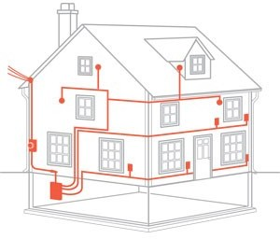
Electrical wiring is generally refers to insulated conductor used to carry current and associated device. This article describes general aspects of electrical wiring as used to provide power in buildings and structures, commonly referred to as building wiring.

Types of wiring according to uses
- Domestic wiring.
- Commercial wiring.
- Industrial wiring.

FACTOR AFFECTING THE CHOICE OF WIRING:

- Durability: Type of wiring selected should conform to standard specifications, so that it is durable i.e. without being affected by the weather conditions, fumes etc.
- Safety: The wiring must provide safety against leakage, shock and fire hazards for the operating personnel.
- Appearance: Electrical wiring should give an aesthetic appeal to the interiors.
- Cost: It should not be prohibitively expensive.
- Accessibility: The switches and plug points provided should be easily accessible. There must be provision for further extension of the wiring system, if necessary.
- Maintenance Cost: The maintenance cost should be a minimum
- Mechanical safety: The wiring must be protected against any mechanical damage

Types of Wiring
- Cleat wiring
- CTS wiring or TRS wiring or batten wiring
- Metal sheathed wiring or lead sheathed wiring
- Casing and capping
- Conduit wiring

Cleat Wiring:

Introduction

The types of wiring to be adopted is dependent on various factors, viz, durability, safety, appearance, cost, consumer’s budget etc.

Cleat Wiring

This System uses insulated Cables sub protected in porcelain cleats.

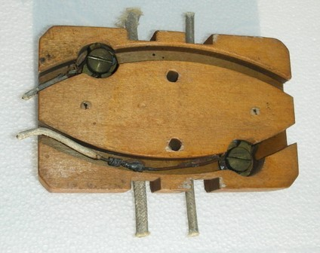

Cleat wiring is recommended only for temporary installations. The cleats are made in pairs having bottom and top halves. The bottom half is grooved to receive the wire and the top half is for cable grip. Initially the bottom and top cleats are fixed on the wall loosely according to the layout. Then the cable is drawn, tensioned and the cleats are tightened by the screw. Cleats are of three types, having one, two or three grooves, so as to receive one, two or three wires. Two types of cleats.

Cleat wiring is one of the cheapest wiring considering the initial cost and labor, and is most suitable for temporary wiring. This wiring can be quickly installed, easily inspected and altered. When not required, this wiring could be dismantled without damage to the cables, cleats and accessories.

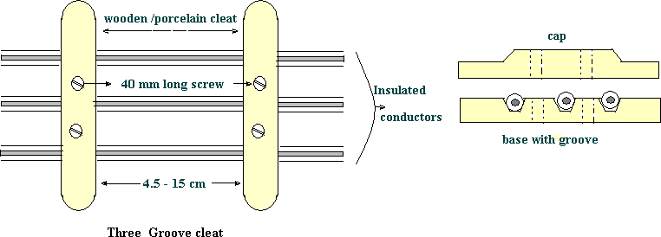

- Cleats
All cleats shall consist of two parts, a base piece and a cap. Cleats shall be fixed at distances not more than 60 cm apart and at regular intervals.
Where cleat wiring is laid along an iron joist, porcelain cleats shall be inserted either with varnished wood fillets or varnished wood clamps

securely fixed so as to prevent the conductors from coming in contact with the metal along witch they are passing.

- Fixing of cleats

In ordinary cases, cleats shall be attached to wooden plugs fixed to the walls.

- Distance apart of wires

For pressure up to 250 volts, cleats shall be of such dimensions that in the case of branch loads, conductors shall not be less than 2.5 cm apart, centre to centre, and in the case of sub-mains not less than 4 cm apart, centre to centre. Care shall be taken in selecting the size of cleats particularly for branch distribution wiring where two-way and three- way porcelain cleats are essential and the difference in size shall be reasonable. Care should also be taken ensure that grooves f porcelain cleats are essential and the difference in size shall be reasonable. Care should also be taken ensure that grooves of porcelain cleats do not compress the insulation nor be too wide for a loose fit. Under no circumstances two wires shall be placed in one groove of the porcelain cleats.

Advantages:
- Easy installation.
- Materials can be retrieved for reuse.
- Flexibility provided for inspection, modifications and expansion.
- Relatively economical.
- Skilled manpower not required.

Disadvantages:

- Appearance is not good.
- Open system of wiring requiring regular cleaning.
- Higher risk of mechanical injury.

Batten Wiring

In this wiring system, wires sheathed in tough rubber are used which are quite flexible. They are clipped on wooden battens with brass clips (link or joint) and fixed on to the walls or ceilings by flat head screws.

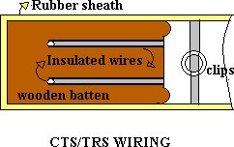
These cables are moisture and chemical proof. They are suitable for damp climate but not suitable for outdoor use in sunlight. TRS wiring is suitable for lighting in low voltage installations.

Advantages:
  - Easy installation and is durable
  - Lower risk of short circuit.
  - Cheaper than casing and capping system of wiring
  - Gives a good appearance if properly erected.

Disadvantages:
- Danger of mechanical injury.
- Danger of fire hazard.
- Should not be exposed to direct sunlight.
- Skilled workmen are required.

Metal Sheathed or Lead Sheathed wiring:
The wiring is similar to that of CTS but the conductors (two or three) are individually insulated and covered with a common outer lead- aluminum alloy sheath. The sheath protects the cable against dampness, atmospheric extremities and mechanical damages. The sheath is earthed at every junction to provide a path to ground for the leakage current. They are fixed by means of metal clips on wooden battens. The wiring system is very expensive. It is suitable for low voltage installations.

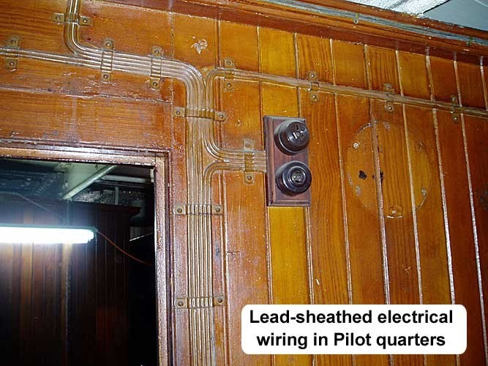

Precautions to be taken during installation:
- The clips used to fix the cables on battens should not react with the sheath.
- Lead sheath should be properly earthed to prevent shocks due to leakage currents.
- Cables should not be run in damp places and in areas where chemicals (may react with the lead) are used.

Advantages:
- Easy installation and is aesthetic in appearance.
- Highly durable.
- Suitable in adverse climatic conditions provided the joints are not exposed.

Disadvantages:
- Requires skilled labor.
- Very expensive.
- Unsuitable for chemical industries.

Casing and Capping:
It consists of insulated conductors laid inside rectangular, teakwood or PVC boxes having grooves inside it. A rectangular strip of wood called capping having same width as that of casing is fixed over it. Both the casing and the capping are screwed together at every 15 cms. Casing is attached to the wall. Two or more wires of same polarity are drawn through different grooves. The system is suitable for indoor and domestic installations.
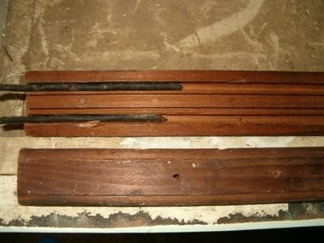
- Cheaper than lead sheathed and conduit wiring.
- Provides good isolation as the conductors are placed apart reducing the risk of short circuit.
Advantages:
- Easily accessible for inspection and repairs.
- Since the wires are not exposed to atmosphere, insulation is less affected by dust, dirt and climatic variations.

Disadvantages:
- Highly inflammable.
- Usage of unseasoned wood gets damaged by termites. Skilled workmanship required

Conduit wiring:

In this system PVC (polyvinyl chloride) or VIR cables are run through metallic or PVC pipes providing good protection against mechanical injury and fire due to short circuit. They are either embedded inside the walls or supported over the walls, and are known as concealed wiring or surface conduit wiring (open conduit) respectively. The conduits are buried inside the walls on wooden gutties and the wires are drawn through them with fish (steel) wires. The system is best suited for public buildings, industries and workshops.

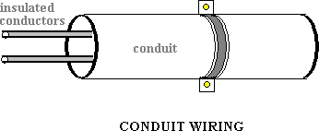

Advantages:
- No risk of fire and good protection against mechanical injury.
- The lead and return wires can be carried in the same tube.
- Earthing and continuity is assured.
- Waterproof and trouble shooting is easy.
- Shock- proof with proper earthing and bonding

- Durable and maintenance free
- Aesthetic in appearance

Disadvantages:
- Very expensive system of wiring.
- Requires good skilled workmanship.
- Erection is quiet complicated and is time consuming.
- Risk of short circuit under wet conditions (due to condensation of water in tubes).

Specification of Wires:

The conductor material, insulation, size and the number of cores, specifies the electrical wires. These are important parameters as they determine the current and voltage handling capability of the wires. The conductors are usually of either copper or aluminum. Various insulating materials like PVC, TRS, and VIR are used. The wires may be of single strand or multi strand. Wires with combination of different diameters and the number of cores or strands are available.
For example: The VIR conductors are specified as 1/20, 3/22,….7/20
………
The numerator indicates the number of strands while the denominator corresponds to the diameter of the wire in SWG (Standard Wire Gauge). SWG 20 corresponds to a wire of diameter 0.914mm, while SWG 22 corresponds to a wire of diameter 0.737 mm.
A 7/0 wire means, it is a 7-cored wire of diameter 12.7mm (0.5 inch). The selection of the wire is made depending on the requirement considering factors like current and voltage ratings, cost and application.
Example: Application: domestic wiring
- Lighting - 3/20 copper wire
- Heating - 7/20 copper wire
The enamel coating (on the individual strands) mutually insulates the strands and the wire on the whole is provided with PVC insulation. The current carrying capacity depends on the total area of the wire. If cost

is the criteria then aluminum conductors are preferred. In that case, for the same current rating much larger diameter of wire is to be used.

SWITCHES:

In electrical engineering, a switch is an electrical component that can break an electrical circuit, interrupting the current or diverting it from one conductor to another.

The most familiar form of switch is a manually operated electromechanical device with one or more sets of electrical contacts, which are connected to external circuits. Each set of contacts can be in one of two states: either "closed" meaning the contacts are touching and electricity can flow between them, or "open", meaning the contacts are separated and the switch is nonconducting. The mechanism actuating the transition between these two states (open or closed) can be either a "toggle" (flip switch for continuous "on" or "off") or "momentary" (push-for "on" or push-for "off") type.

A switch may be directly manipulated by a human as a control signal to a system, such as a computer keyboard button, or to control power flow in a circuit, such as a light switch. Automatically operated switches can be used to control the motions of machines, for example, to indicate that a garage door has reached its full open position or that a machine tool is in a position to accept another work piece. Switches may be operated by process variables such as pressure, temperature, flow, current, voltage, and force, acting as sensors in a process and used to automatically control a system. For example, a thermostat is a temperature-operated switch used to control a heating process. A switch that is operated by another electrical circuit is called a relay. Large switches may be remotely operated by a motor drive mechanism. Some switches are used to isolate electric power from a system, providing a visible point of isolation that can be padlocked if necessary to prevent accidental operation of a machine during maintenance, or to prevent electric shock.

In circuit theory:
An ideal switch would have no voltage drop when closed, and would have no limits on voltage or current rating. It would have zero rise time and fall time during state changes, and would change state without "bouncing" between on and off positions.

Practical switches fall short of this ideal, and have resistance, limits on the current and voltage they can handle, finite switching time, etc. The ideal switch is often used in circuit analysis as it greatly simplifies the system of equations to be solved, however this can lead to a less accurate solution. Theoretical treatment of the effects of non-ideal properties is required in the design of large networks of switches, as for example used in telephone exchanges.

Various Type OF Switches:

SPST:

Single Pole Single Throw: A simple on-off switch: The two terminals are either connected together or disconnected from each other. An example is a light switch.

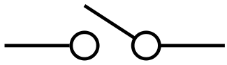

SPDT:
Single pole, double throw: A simple changeover switch: C (COM, Common) is connected to L1 or to L2.

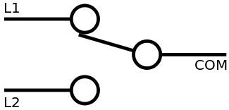

SPCO, SPTT:
Single Pole Change Over OR Single Pole Centre OFF OR Single Pole Triple Throw: Similar to SPDT. Some suppliers use SPCO/SPTT for switches with a stable off position in the centre and SPDT for those without.

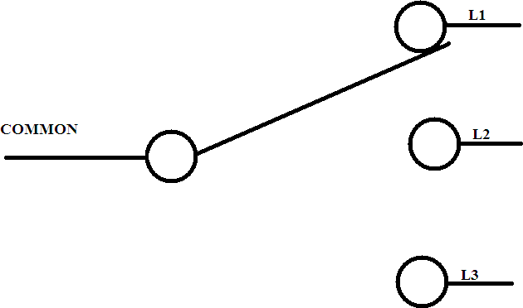

DPST:
Double Pole Single Throw: Equivalent to two SPST switches controlled by a single mechanism.

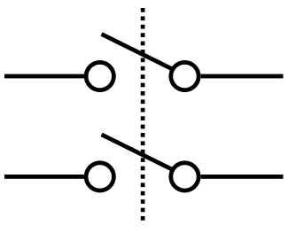

DPDT:
Double pole Double Throw: Equivalent to two SPDT switches controlled by a single mechanism.

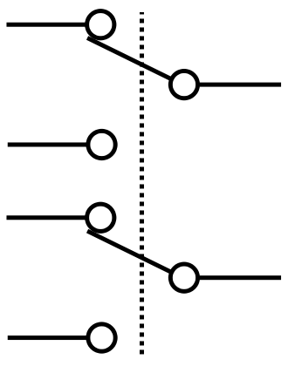

DPCO:
Double Pole Change Over OR Double Pole Centre OFF: Equivalent to DPDT. Some suppliers use DPCO for switches with a stable off position in the centre and DPDT for those without.

INTERMEDIATE SWITCH:
DPDT switch internally wired for polarity-reversal applications: only four rather than six wires are brought outside the switch housing.

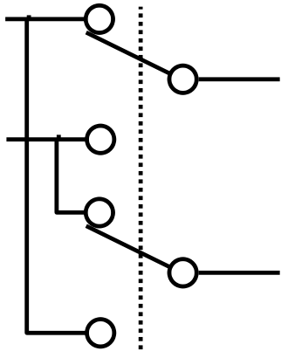

MANUFACTURING COMAPNIES:
ANCHOR SWITCHES:

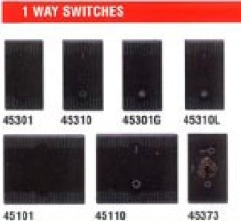
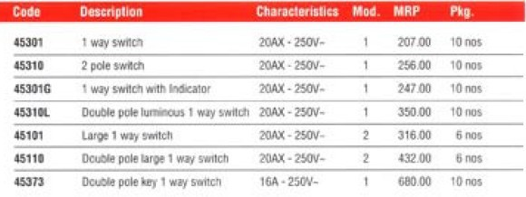

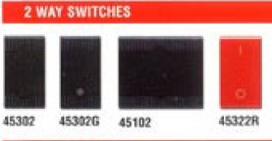
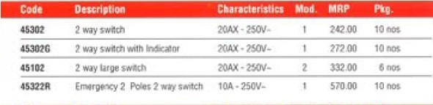
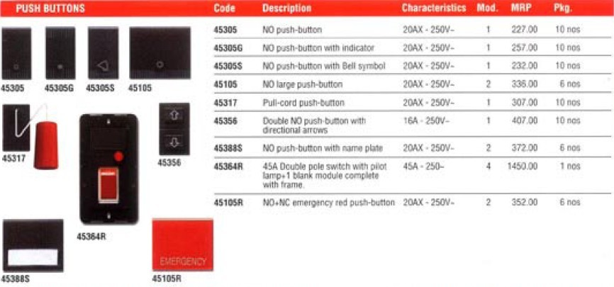

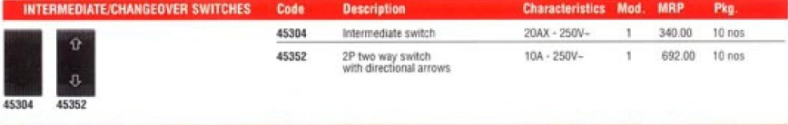
HAVELLS SWITCHES:

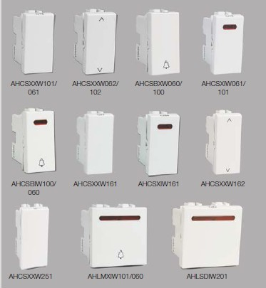

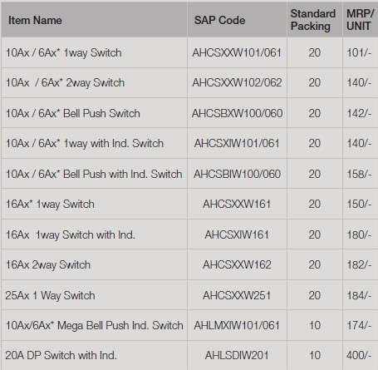
AC POWER PLUG AND
SOCKETS:
AC power plugs and sockets are devices that allow electrically operated devices to be connected to the primary alternating current (AC) power
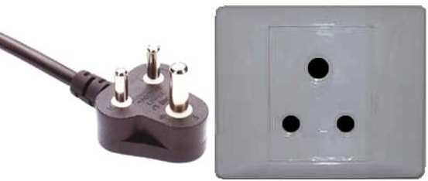
supply in a building. Electrical plugs and sockets differ in voltage and current rating, shape, size and type of connectors. The types used in each country are set by national standards.

Generally the plug is the movable connector attached to an electrically operated device's mains cable, and the socket is fixed on equipment or a building structure. Plugs have male circuit contacts, while sockets have female contacts. The plug has protruding prongs, blades, or pins that fit into matching slots or holes in the socket. A socket is also called a receptacle, outlet, or power point (British English). It may be surrounded by a cover called a wall plate, face plate, outlet cover, socket cover, or wall cover.

To reduce the risk of electric shock, plug and socket systems can incorporate safety features. These may include socket design intended to accept only compatible plugs inserted in the correct orientation; plugs with insulated sleeves on contact pin shanks so a partially inserted plug does not bear exposed live pins that could be touched; or sockets with blocking shutters that open only when a compatible plug is inserted. Sockets are designed to prevent exposure of bare live contacts. The exposed contacts present in some sockets are used exclusively for earthing (grounding).

ANCHOR SOCKETS:

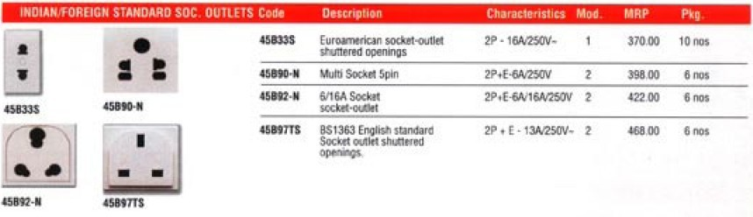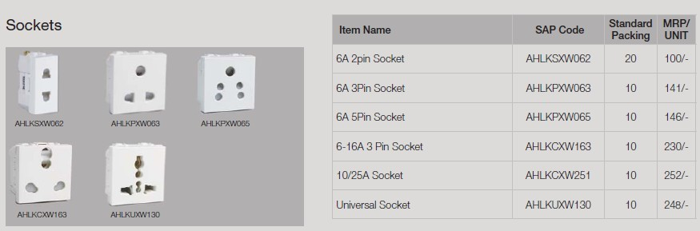
HAVELLS SOCKET:

COMPARISON BETWEEN PRICE OF THREE MANUFACTURING COMPANY:

Sr No. | ANCHOR | HAVELLS | WIPRO | COMMENTS
1. | 1-WAY SWITCH 20A-250V Rs.207 | 1-WAY SWITCH 10A-250V Rs.101 | 1-WAY SWITCH 6A-250V Rs.101 | HAVELLS IS BEST WITH MEDIUM RATING AND RESONABLE PRICE
2. | 2-WAY SWITCH 20A-250V  Rs.256 | 2-WAY SWITCH 10A-250V  Rs.140 | 2-WAY SWITCH 6A-250V  RS.122 | WIPRO IS BEST WITH RESONABLE  PRICE
3. | 1-WAY SWITCH WITH LED 20A-250V Rs.247 | 1-WAY SWITCH WITH LED 10A-250V Rs.140 | 1-WAY SWITCH WITH LED 6A-250V Rs.133 | AGAIN WIPRO IS BEST WITH RESONABLE PRICE
4. | 2-WAY SWITCH WITH LED 20A-250V Rs.272 |  | 2-WAY SWITCH WITH LED 6A-250V Rs.172 | WIPRO IS BEST WITH RESONABLE PRICE

Sr No. | ANCHOR | HAVELLS | WIPRO | COMMENTS
1. | 2 PIN  16A/25  0V SOCK ET  Rs.332 | 6A 2 PIN  SOCK ET  Rs.100 | 6A 2/3PIN SOCK ET  Rs.170 | HAVELLS IS BEST FOR IT LOW PRICE

2. | 2 PIN +E  16A/250V Rs.346 | 6A 3 PIN  SOCK ET  Rs.141 | 6A 2 AND 3 PIN SOCK ET  Rs.240 | HAVELLS IS BEST FOR IT LOW PRICE
3. | 6A-16A  SOCK ET  Rs.367 | 6-16A 3 PIN  SOCK ET  Rs.230 | 6/16A 6 PIN  SOCK ET  Rs.265 | AGAIN  HAVEL LS IS BEST FOR IT LOW PRICE

